**Caregiver Benefits Application (10-10CG)**

**Table of Contents**

Caregiver Benefits Application Overview 2

**User Access** 2

**Who can access this application?** 2

**Navigation** 3

How Do I Apply 4

Caregiver Benefits Application 7

**Veteran Information** 7

**Veteran Health Care Information** 11

**Primary Family Caregiver Information** 13

**Primary Family Caregiver Health Care Information** 17

**Secondary Family Caregiver Information** 20

**Secondary Family Caregiver (2) Information** 26

Review and Submission 30

**Reviewing the Application** 30

**Submitting the Application** 33

**Troubleshooting a Submission Error** 35

# Caregiver Benefits Application Overview

This product guide covers the online application for caregiver benefits through the Program of Comprehensive Assistance for Family Caregivers (10-10CG).

## **User Access**

### **Who can access this application?**

This application is completed by Veterans and family caregivers; each applicant completes their own section of the form and all are required to check a confirmation box on the submission page. Unlike other forms on VA.gov. applicants do not sign in to complete the online version of the 10-10CG. You can reference the below screenshot for more information on eligibility:

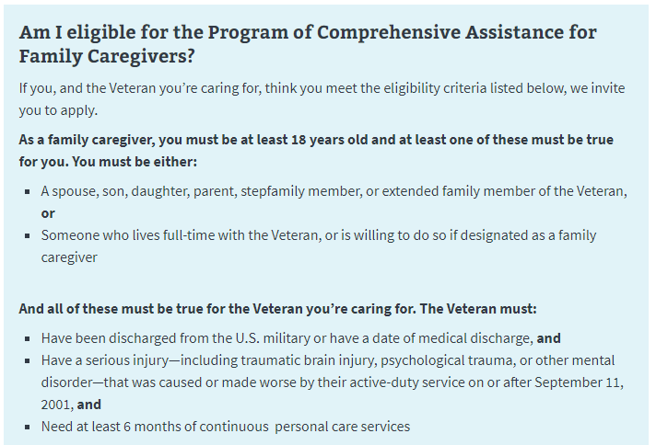

The program is available to veterans and service members on active duty and undergoing a medical discharge. They’ll first need to apply for VA health care benefits (VA Form 10-10EZ) before applying for family caregiver benefits.

### **Navigation**

Direct url: <https://www.va.gov/family-member-benefits/apply-for-caregiver-assistance-form-10-10cg/>

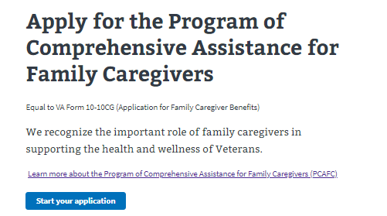

Or, information about the program, as well as a link to the form, can be found on the Program of Comprehensive Assistance for Family Caregivers page: <https://www.va.gov/family-member-benefits/comprehensive-assistance-for-family-caregivers/>

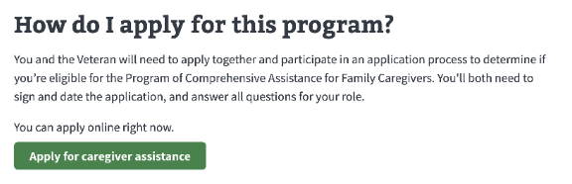

# How Do I Apply

The application page provides instructions on how to apply for family caregiver benefits and what information is needed to complete the form. This page also directs the user to the application once they are ready to apply:

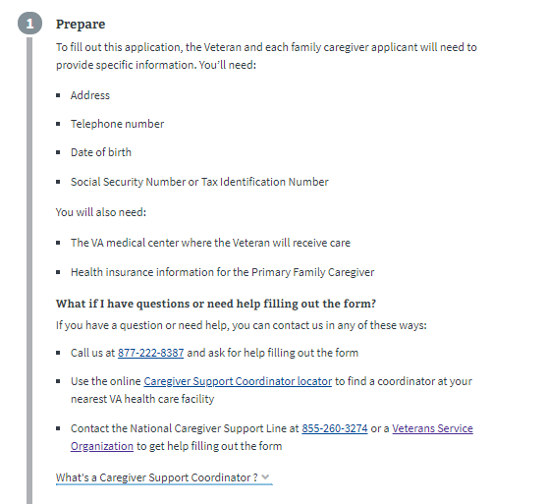

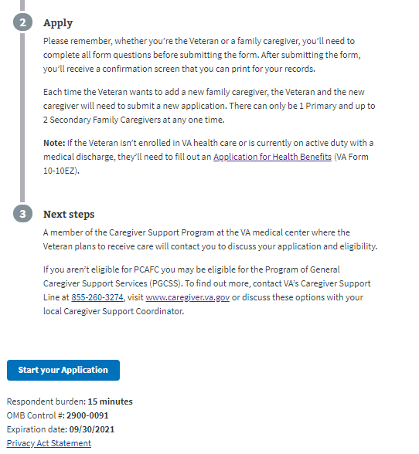

A dropdown link gives applicants additional information about caregiver support program coordinators.

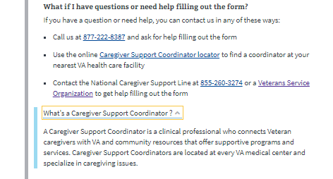

# Caregiver Benefits Application

### **Veteran Information**

First, the Veteran will be asked to fill in general personal information.

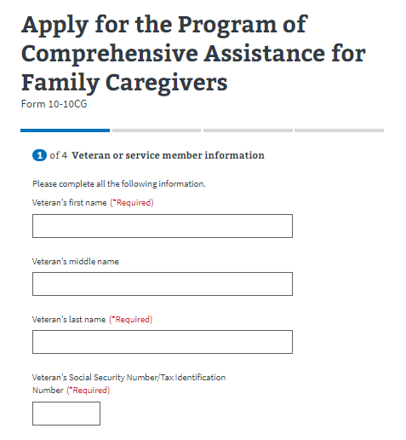

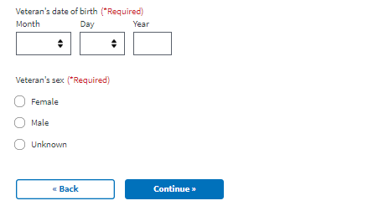

The application will tell the veteran what must be filled in. If they do not enter all the required information, they will not be allowed to move on to the next page.

Next, the Veteran will be asked to fill in contact information.

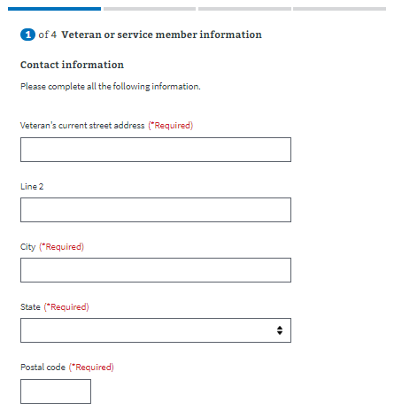

Primary phone number is required so a caregiver support coordinator can contact the Veteran to discuss the application. Email is not a required field.

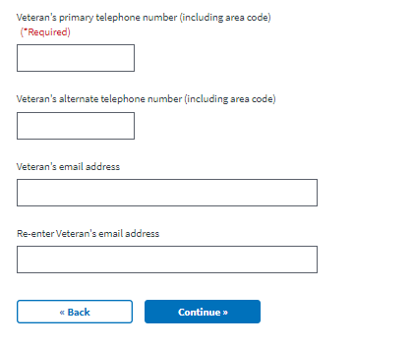

If they do not enter all the required information, they will not be allowed to move on to the next page.

### **Veteran Health Care Information**

Next, the Veteran will be asked to enter information about where they last received health care services, and where they plan to get VA health care:

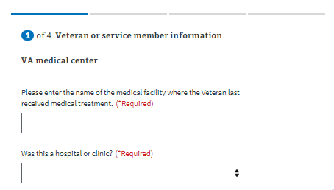

Then, the Veteran will be asked where they plan to receive VA health care. This is so the application can be reviewed by a caregiver support coordinator at that location. Ideally, the Veteran will choose the VA medical center closest to their home. If they don’t know the closest medical center or clinic, they can use the facility locator tool, which opens up this URL:  
<https://www.va.gov/find-locations?_ga=2.122325512.262714775.1592836694-667793174.1588616125>

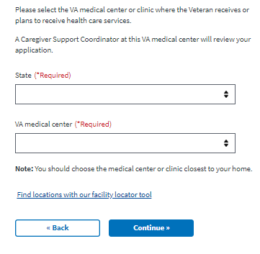

### **Primary Family Caregiver Information**

Next, the person applying to be the primary family caregiver will be asked to enter general personal information.

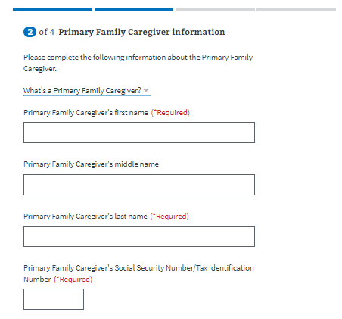

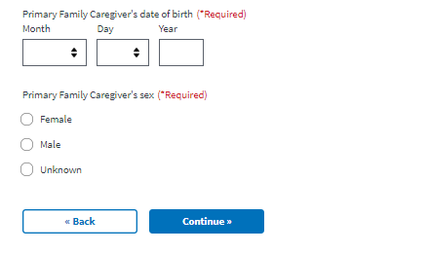

The application will tell the primary family caregiver what must be filled in. If they do not enter all the required information, they will not be allowed to move on to the next page.

The definition of a primary family caregiver can be accessed through a dropdown link.

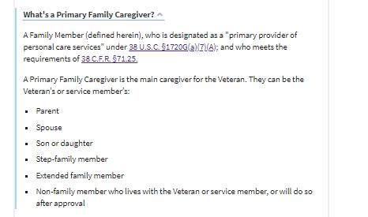

Next, the primary family caregiver will be asked to fill in contact information.

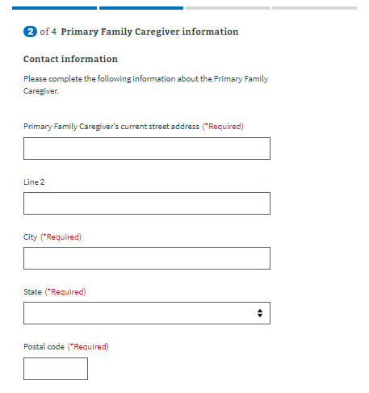

Primary phone number is required so a caregiver support coordinator can contact the primary family caregiver to discuss the application. Email is not a required field.

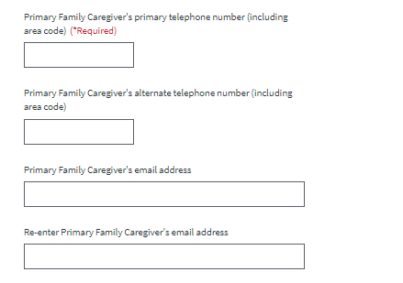

A dropdown menu prompts the primary family caregiver to indicate their relationship with Veteran. The form will not continue unless the applicant provides a response.

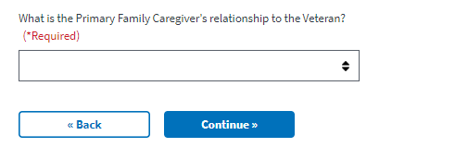

### **Primary Family Caregiver Health Care Information**

Next, the primary family caregiver will be asked about their current health care coverage. They will be required to answer “yes” or “no” to questions about Medicaid, Medicare, CHAMPVA and Tricare.

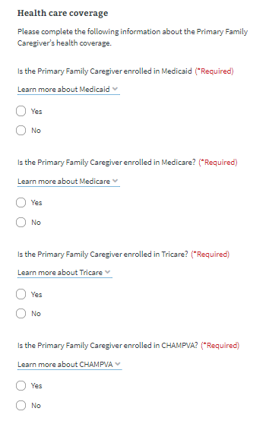

Definitions of each medical option are available by clicking a link:

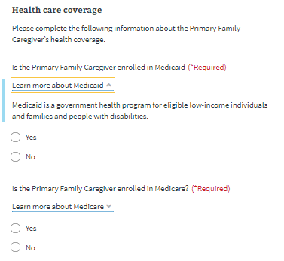

The primary family caregiver will be asked if they receive health care other than Medicaid, Medicare, CHAMPVA or Tricare.

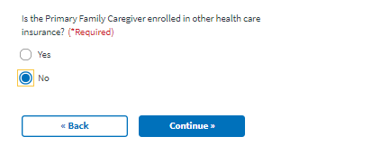

If they say yes, an additional field will appear they must fill out to continue. If they are covered by more than one additional heath care program, they should separate the names of the programs with commas.

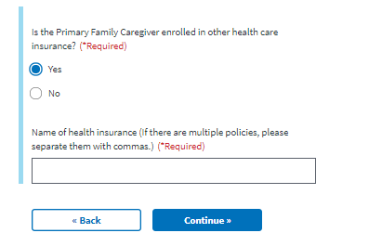

### **Secondary Family Caregiver Information**

Next, the applicants will have to decide if they want to add a secondary family caregiver. Secondary family caregivers are optional, and each veteran can have up to 1 primary family caregiver and 2 secondary family caregivers.

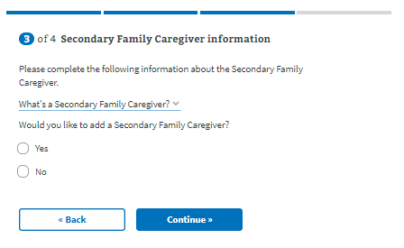

The definition of a secondary family caregiver can be accessed by clicking the dropdown link.

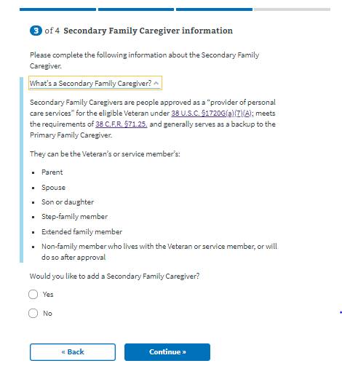

If the applicants do not add a secondary family caregiver, they will advance to the review screen.

If the applications add a secondary family caregiver, additional fields will appear that they must fill out:

The person applying to be the secondary family caregiver will be asked to enter general personal information.

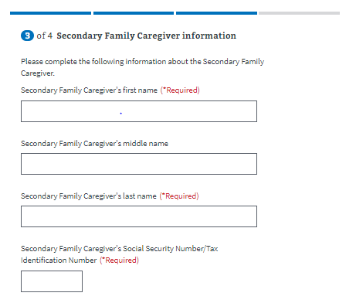

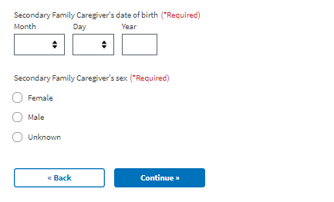

The application will tell the secondary family caregiver what must be filled in. If they do not enter all the required information, they will not be allowed to move on to the next page.

Next, the secondary family caregiver will be asked to fill in contact information.

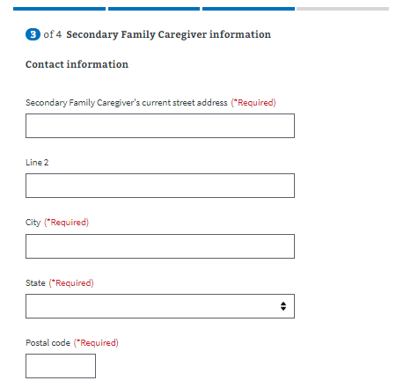

Primary phone number is required so a caregiver support coordinator can contact the secondary family caregiver to discuss the application. Email is not a required field.

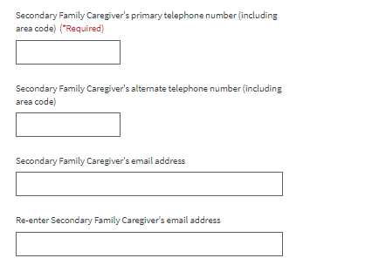

A dropdown menu prompts the secondary family caregiver to indicate their relationship with Veteran. The form will not continue unless the applicant provides a response.

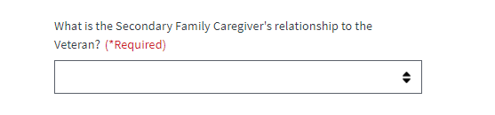

Applicants are then asked if they would like to add another secondary family caregiver. If the applicants do not add a second secondary family caregiver, they will advance to the review screen.

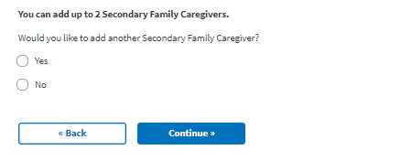

If they add a second secondary family caregiver, they will advance to a new screen.

### **Secondary Family Caregiver (2) Information**

Next, the person applying to be the secondary family caregiver (2) will be asked to enter general personal information.

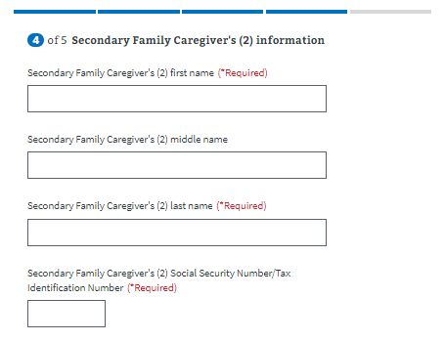

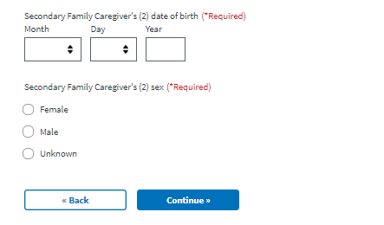

The application will tell the secondary family caregiver (2) what must be filled in. If they do not enter all the required information, they will not be allowed to move on to the next page.

Next, the secondary family caregiver (2) will be asked to fill in contact information.

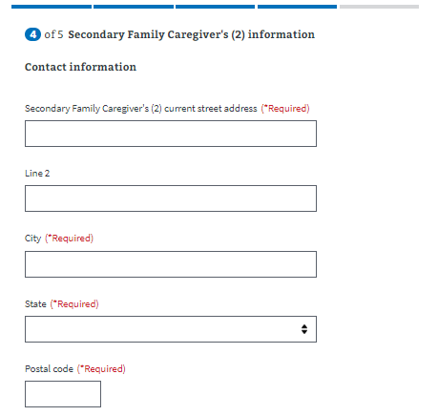

Primary phone number is required so a caregiver support coordinator can contact the secondary family caregiver to discuss the application. Email is not a required field.

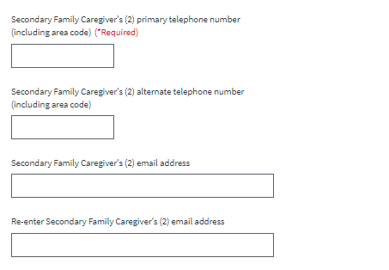

A dropdown menu prompts the second secondary family caregiver to indicate their relationship with Veteran. The form will not continue unless the applicant provides a response.

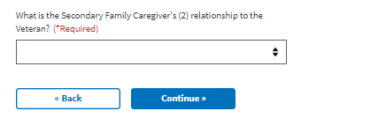

# Review and Submission

### **Reviewing the Application**

The last step is the review application page. Here, the Veteran and each family caregiver can review the information that they’ve entered by clicking on the plus signs next to a section:

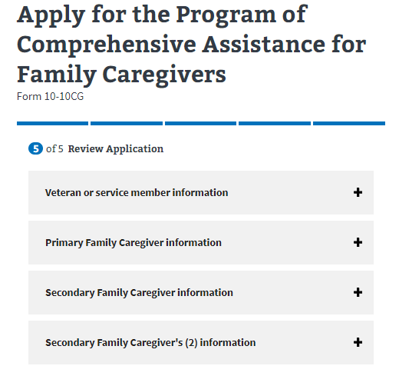

If the Veteran and each caregiver applicant clicks on the plus sign, the section will open and show what the user entered. If something looks wrong, the applicant can select the “edit” button, and will be able to make edits on the information:

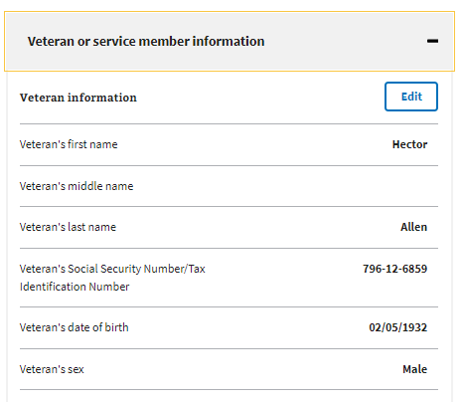

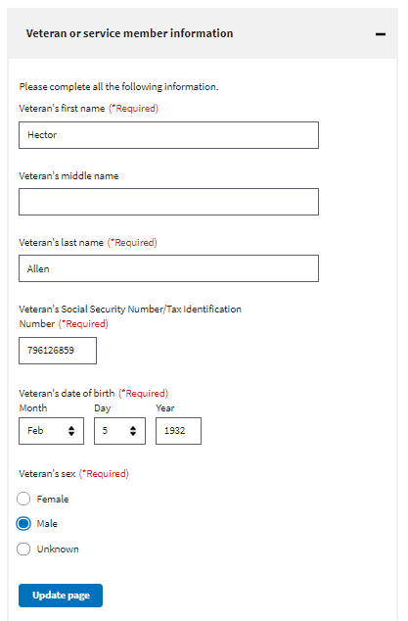

### **Submitting the Application**

Once the Veteran and each caregiver applicant has reviewed the information and made any changes, they can select to submit the application. They can only successfully submit the application after each of them type their full name and select the “I certify the information is correct and true to the best of my knowledge and belief” button.

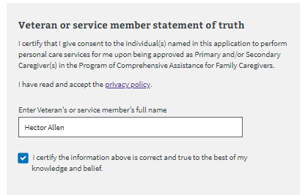

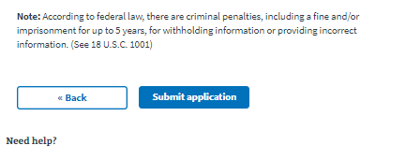

After selecting “submit application” the applicants will be shown the below page which contains a summary of the information, as well as additional information links that can help them understand the process for their application. They will also be able to print out the verification page and keep it for their records:

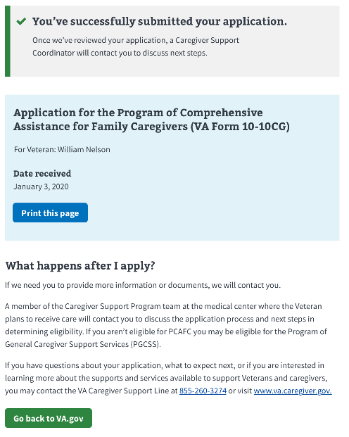

### **Troubleshooting a Submission Error**

If the application fails to submit, the applicant will receive the following error message on the Review and Submission page.

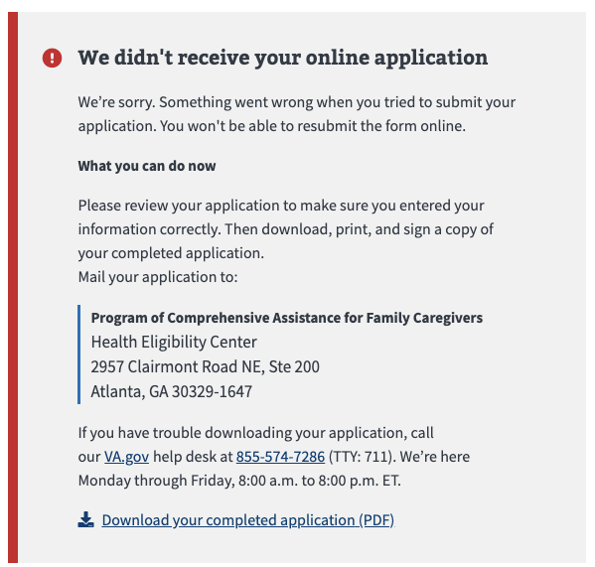

If the applicant receives this error, they should carefully review the information that they entered into the form. If they see an error, they can fix it in the “review” field.

They will not be able to resubmit their online application unless they close their browser and start a new session. However, they can click the “download your completed application (PDF) link at the bottom of the error message. The completed PDF will be saved to their computer.

Once they print out the completed PDF, the Veteran and each of the family caregiver applicants will need to checkmark the acknowledgment and sign. The application can be mailed to the address listed in the error message.